11. ReactJS-HOL

Create a React Application “eventexamplesapp” to handle various events of the form elements in

HTML.

1. Create “Increment” button to increase the value of the counter and “Decrement” button to decrease the value of the counter. The “Increase” button should invoke multiple methods.
   1. To increment the value
   2. Say Hello followed by a static message.

# code:

PS C:\Users\lenovo> node –v V22.17.0

PS C:\Users\lenovo> npm -v 10.9.2

PS C:\Users\lenovo> npx create-react-app eventexamplesapp PS C:\Users\lenovo\ eventexamplesapp > npm start

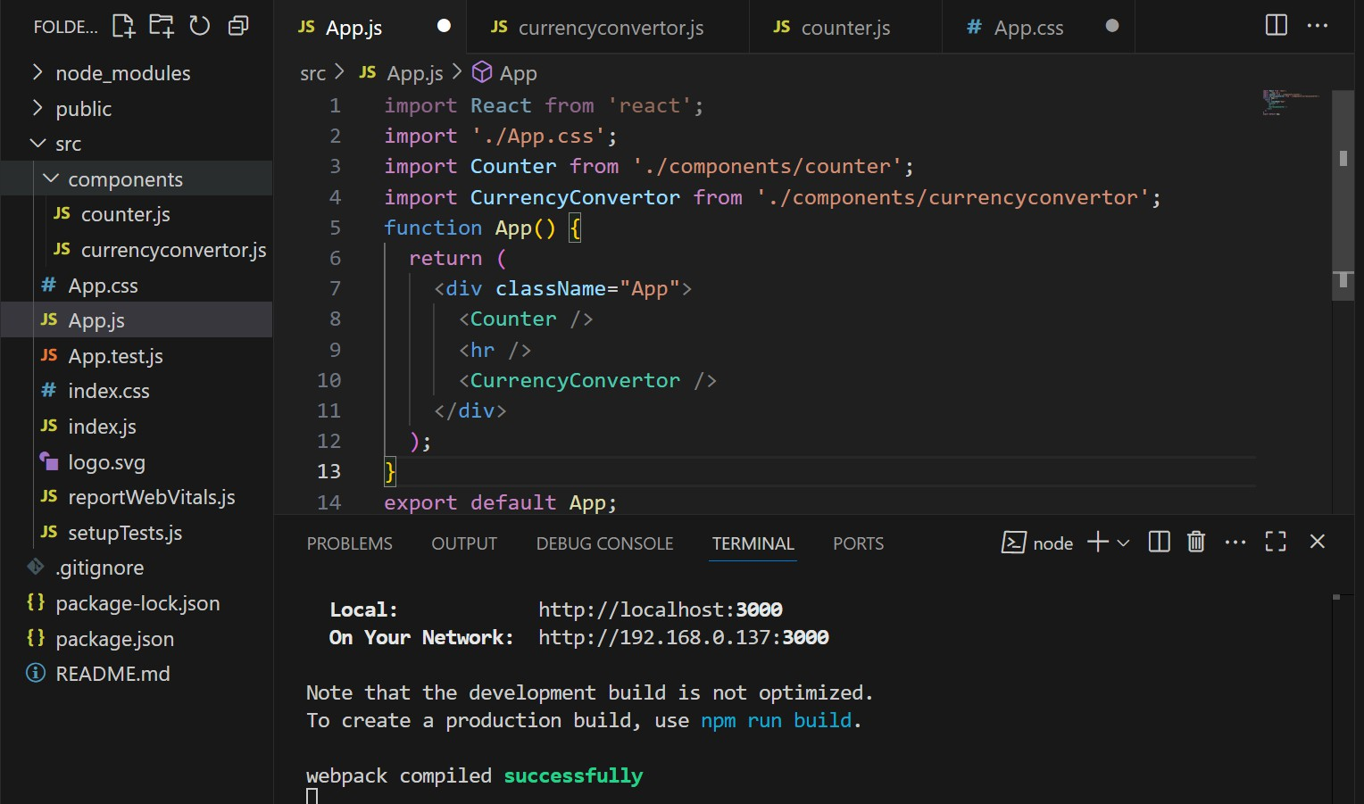

Src/components/counter.js

import React, { useState } from 'react';

const Counter = () => {

const [count, setCount] = useState(5);

const increment = () => { setCount(prev => prev + 1);

console.log("Hello! You clicked increment.");

};

const decrement = () => { setCount(prev => prev - 1);

};

const sayWelcome = (message) => { alert(message);

};

return (

<div>

<h2>{count}</h2>

<button onClick={increment}>Increment</button>{' '}

<button onClick={decrement}>Decrement</button><br /><br />

<button onClick={() => sayWelcome("welcome to this page")}>Say welcome</button>{' '}

<button onClick={() => alert("I was Clicked!")}>Click on me</button>

</div>

);

};

export default Counter;

Src/components/currencyconvertor.js

import React, { useState } from 'react';

const CurrencyConvertor = () => {

const [euro, setEuro] = useState('');

const handleSubmit = (e) => { e.preventDefault();

const rupees = parseFloat(euro) * 80; // Assuming 1 EUR = ₹80

alert(`Converting to Euro Amount is ${rupees}`);

};

return (

<div style={{ textAlign: 'center', marginTop: '30px' }}>

<h2 style={{ color: 'green' }}>Currency Convertor!!!</h2>

<form onSubmit={handleSubmit}>

<label>Amount: </label>

<input

type="number" value={euro}

onChange={(e) => setEuro(e.target.value)} required

/>

<br /><br />

<label>Currency: </label>

<input

type="text" value="Euro" disabled

style={{ width: '150px' }}

/>

<br /><br />

<button type="submit">Submit</button>

</form>

</div>

);

};

export default CurrencyConvertor;

# Output:

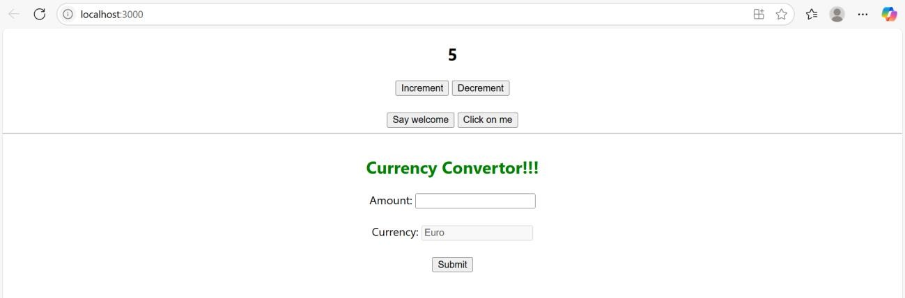

Onclick=’Saywelcome’

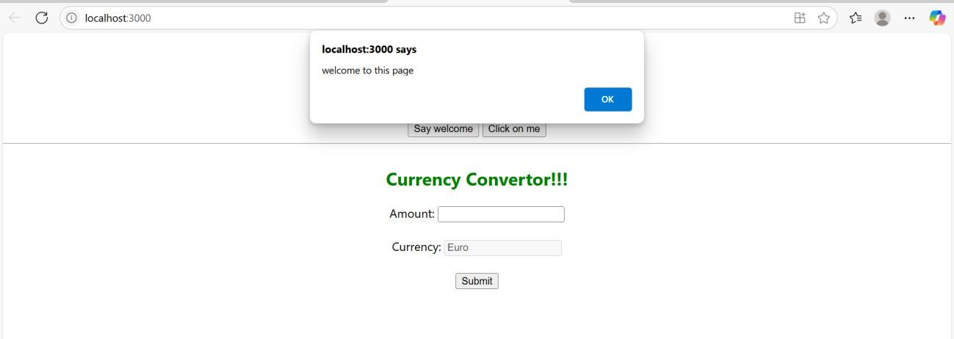

**Create a button which invokes synthetic event “OnPress” which display “I was clicked”**

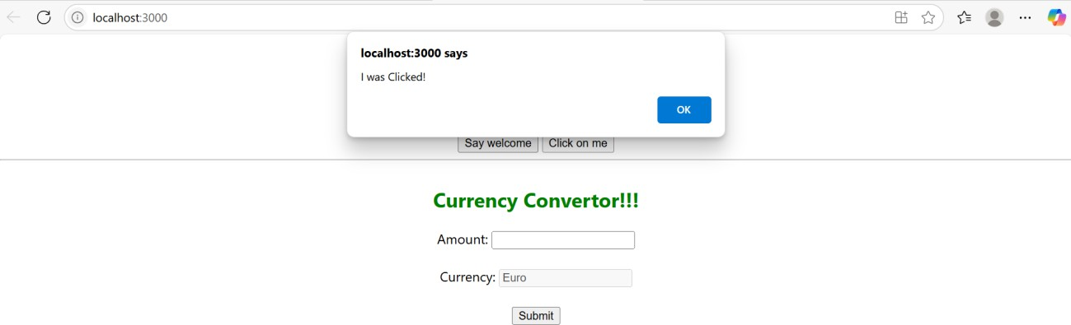

Create a “CurrencyConvertor” component which will convert the Indian Rupees to Euro when the Convert button is clicked.

Handle the Click event of the button to invoke the handleSubmit event and handle the conversion

of the euro to rupees.

